Semester One - Week 4:
Settling on the Topic and Title of your Research Study

These notes guide you through choosing a workable research topic and shaping it into a clear, researchable title. In practice, your topic and title act as the “anchor” for all later decisions: the literature you review, the variables or concepts you define, the population you choose, and the study design you adopt. The goal is not to find a perfect topic on day one, but to develop a well-justified, manageable topic and a working title that you can refine as the project develops.
A. What is a research topic, and why it matters.
A research topic is the central subject or issue you decide to study in depth. It becomes the basis for your research question(s), methodology and findings. A well-defined topic keeps the study focused and coherent, while a vague topic can lead to an unfocused and disjointed project.
ICT examples of research topics:
• Cybersecurity behaviour: How small businesses implement password policies and multi-factor authentication in practice.
• Human–Computer Interaction (HCI): Usability challenges experienced by first-year students using a university learning management system (LMS).
• AI in education: How students use generative AI tools for programming support and how this affects learning outcomes and academic integrity.
• Software engineering: Factors influencing the adoption of automated testing in small development teams.

B. Starting points for identifying a topic
If you feel “stuck”, start with what you already have: your interests, real problems you observe in ICT settings, and your developing skills. A simple way is to brainstorm possible topics, then narrow them down through reading and feasibility checks.

A practical topic-formulation process:

C. Criteria for selecting a good topic (and avoiding common traps)
When selecting a research problem/topic, keep these criteria in mind. They help you choose a study you can complete, and they protect you from topics that are interesting but unrealistic.
Core criteria to apply to your topic choice:
- Interest: Choose something you genuinely care about, because research takes time and persistence.
- Magnitude and manageability: Narrow the topic so it can be completed with the time, resources, and data access you have.
- Relevance and contribution: Select a topic that is useful to your field and adds to existing knowledge or solves a practical problem.
- Availability of data: Confirm that participants, documents, system logs, survey access, or other data sources are realistically available.
- Measurement and clarity of concepts: In quantitative studies, ensure you can define and measure key concepts (e.g., “usability”, “performance”, “security awareness”).
- Level of expertise: Ensure you have (or can realistically develop) the skills needed to collect and analyse the data.
- Ethical acceptability: Identify privacy and consent risks early, especially when collecting user data, system logs, or workplace information.
Common mistakes that weaken topics:
- Too broad: The topic covers too many issues (e.g., “Cybersecurity in South Africa”).
- Too vague: Key terms are unclear (e.g., “Technology and productivity”).
- Low significance or weak relevance: The topic does not solve a real problem or add new insight.
- Poor feasibility: The topic needs data you cannot access (e.g., confidential corporate datasets without permission).
- Weak alignment with literature: You cannot find enough credible sources to support the study.

D. Turning a topic into a working title
A working (draft) title is a practical tool: it keeps you focused and gives others a clear idea of what your study is about. It is normal for the title to change as your study becomes more refined.
A simple drafting technique:
• Complete the sentence: “My study is about …”
Then rewrite it as a title that another person can understand quickly.
Guidelines for a strong research title:
• Be brief and avoid wasting words (avoid filler like “A study of …” unless needed).
• Aim for a title that is easy to read and not overly complex.
• Use a single title or a double title (main title + clarifying subtitle) if helpful.
• Include the key focus of the study (topic, setting, population, or key concept), without trying to include every detail.
• Consider limiting the title to about 12 words, and remove unnecessary articles and prepositions.
ICT title examples (single title):
• Factors Influencing Adoption of Multi-Factor Authentication in Small Businesses
• Usability Barriers in a University Learning Management System for First-Year ICT Students
ICT title examples (double title):
• An HCI Case Study: Improving Mobile Navigation for Low-Bandwidth Users
• AI Support in Programming Education: Student Use of Generative Tools in Introductory Coding Modules

E. Narrowing the scope: the “boundary settings” that make a topic researchable
Many beginners choose a topic that is interesting but too wide. Narrowing is not ‘making it smaller’ only; it is defining the boundaries so the study has a clear focus.
Use these boundaries to narrow your topic:
• Population: Who/what are you studying (e.g., first-year ICT students, small retail businesses, software developers in one company)?
• Setting: Where will the study take place (e.g., one campus, one organisation, one online platform)?
• Timeframe: What period will you focus on (e.g., one semester; last 6 months of support tickets)?
• Key concept(s): What exactly are you studying (e.g., user satisfaction, adoption barriers, perceived usefulness, error rates)?
• Data source(s): What evidence will you use (survey, interviews, observation, system logs, documents, usability tests)?
Mini-example (how narrowing changes a topic):
• Broad topic: “AI in education”
• Narrowed topic: “How first-year ICT students use generative AI tools to debug code in an introductory programming module during Semester 1”
• Possible working title: “Generative AI for Debugging: First-Year ICT Student Practices in Programming”

F. Worked ICT Examples: Developing a Research Topic
The following ICT examples demonstrate how students can apply the Three Approaches for Developing a Topic:) listing key words, 2) drawing relationships, and 3) defining the topic in sentences.

Example 1: Cybersecurity Awareness in Universities

Approach 1: List Key Words of Interest
Concept 1: Cybersecurity awareness
Concept 2: Phishing attacks

Synonyms: digital security awareness, information security training
Related terms: cyber hygiene, security culture, social engineering

Approach 2: Draw It Out
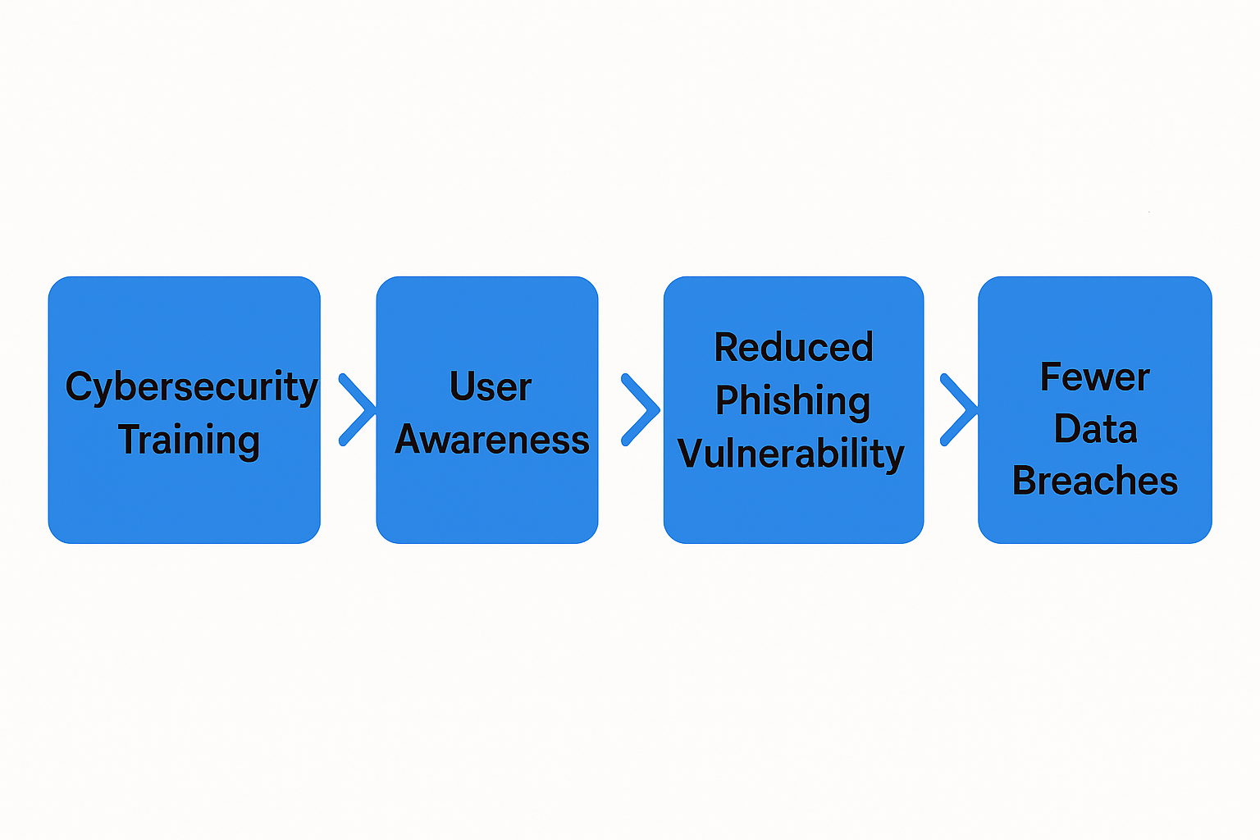
Approach 3: Define it in Sentences
I am studying… cybersecurity awareness training among university students...
in order to find out… whether training reduces phishing vulnerability...
in order to help my reader understand… how universities can strengthen ICT security culture.

Example 1: Recommended Research Title (Best Fit)
Option 1 “The Impact of Cybersecurity Awareness Training on Phishing Vulnerability Among University Students”
This title is strong because it includes:
- Intervention: cybersecurity awareness training
- Outcome: phishing vulnerability
- Population: university students
- Focus: measurable impact

Alternative Title Options:
Option 2 (ICT Security Culture Emphasis)
“Cybersecurity Awareness Training as a Strategy for Strengthening ICT Security Culture in Universities”
This highlights the broader institutional goal.

Option 3 (Behavioural Focus)
“Evaluating the Effectiveness of Cybersecurity Awareness Training in Reducing Phishing Susceptibility Among University Students”
More formal and evaluation-driven.

Option 4 (Higher Education Context)
“Improving Phishing Resistance Through Cybersecurity Awareness Training in Higher Education Institutions”
Good if the institution is the unit of analysis.

Option 5 (Student Preparedness Angle)
“Enhancing University Students’ Preparedness Against Phishing Attacks Through Cybersecurity Awareness Training”
Emphasises skills and readiness.
Title Selection Guidance
If your study is quantitative and intervention-based, the first title is best.
If your study is qualitative and culture-focused, Option 2 may fit better.

Example 2: AI Tools in Software Development Workflows

Approach 1: List Key Words of Interest
Concept 1: AI-assisted software development
Concept 2: Developer productivity
Synonyms: AI coding support, intelligent programming tools
Related terms: GitHub Copilot, ChatGPT for developers, workflow automation

Approach 2: Draw It Out
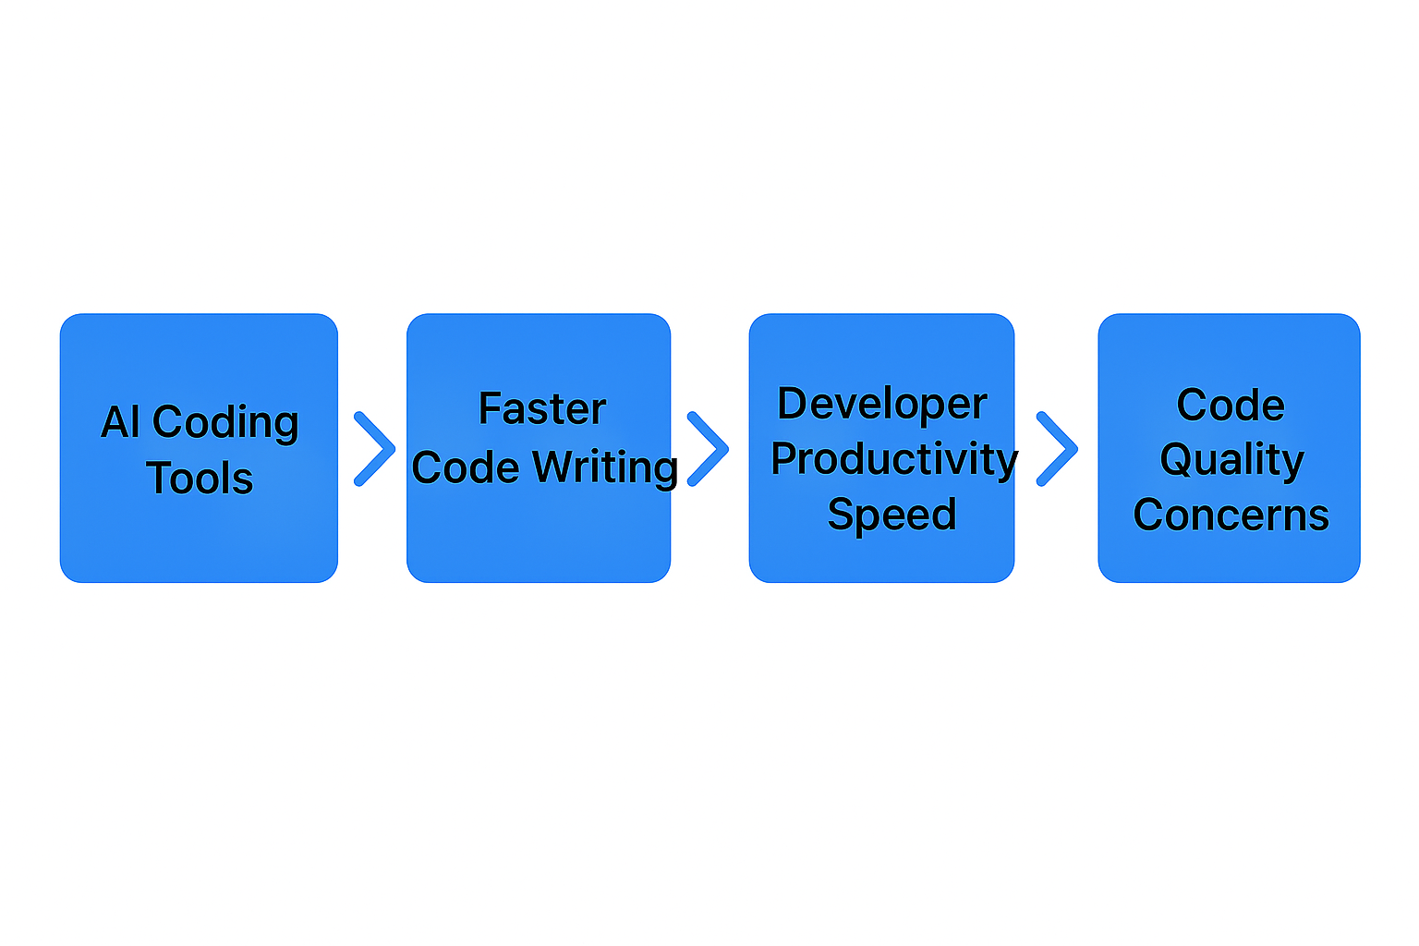
Approach 3: Define it in Sentences
I am studying… the use of AI coding assistants in software development companies...
in order to find out… how these tools affect productivity and reliability...
in order to help my reader understand… how organisations can adopt AI responsibly.

Example 2: Recommended Research Title (Best Fit)
“The Effects of AI Coding Assistants on Developer Productivity and Code Reliability in Software Development Companies”
This is the strongest option because it includes:
- Technology: AI coding assistants
- Outcomes: productivity + reliability
- Context: software development companies
- Clear cause–effect focus

Alternative Title Options (Equally Suitable)
Option 2 (Responsible Adoption Emphasis)
“Responsible Adoption of AI Coding Assistants in Software Development: Impacts on Productivity and Reliability”
Best if your study focuses on governance and responsible integration.

Option 3 (Workplace Integration Focus)
“Exploring the Integration of AI Coding Assistants in Software Development Workflows and Their Impact on Productivity”
Better suited for qualitative or exploratory research.

Option 4 (Organisational Decision-Making Angle)
“Understanding Organisational Use of AI Coding Assistants: Productivity Gains, Reliability Risks, and Responsible Implementation”
Good for a broader socio-technical perspective.

Option 5 (Developer Experience Perspective)
“AI Coding Assistants in Professional Software Development: Effects on Developer Performance, Trust, and Code Quality”
Useful if human-AI collaboration and trust are key themes.

Title Selection Guidance
- If your study is quantitative, choose Option 1 (effects/impact language).
- If your study is qualitative, choose Option 3 or 4 (exploring/understanding language).
- If your focus includes ethics and governance, choose Option 2.

G. Tutorial activity: build your own topic and title
Complete this worksheet for your proposed study:
1) Interest area (what you are curious about in ICT): ________________________________
2) Real-world problem you observe: _______________________________________________
3) Who is affected (population): _________________________________________________
4) Where it happens (setting): _________________________________________________
5) What evidence you can access (data sources): _________________________________
6) Draft “My study is about …” sentence: _______________________________________
7) Working title (single or double title): ________________________________________
8) One-sentence justification: Why this topic matters and is feasible: ________________

H. References
• Kumar, R. (2011). Research Methodology: A Step-by-Step Guide for Beginners.
• Creswell, J. W. (n.d.). Chapter Seven: Research Questions and Hypotheses (course extract).
• Student Research Guide, Department of English. How to Formulate a Research Topic? (course handout). https://www.ln.edu.hk/eng/student-research-guide/how-to-formulate-a-research-topic

I. Lower-order MCQs
1. What is the main purpose of selecting a research topic?
A. To immediately start writing the findings chapter
B. To choose an area of study that is interesting, researchable, and worthwhile
C. To ensure the study uses only quantitative methods
D. To avoid reviewing any literature
Correct Answer: B

2. A good research title should primarily be:
A. Long and highly technical
B. Vague to allow flexibility
C. Clear, specific, and reflective of the study focus
D. Written in the form of a full paragraph
Correct Answer: C

3. Which of the following is an example of a researchable ICT topic?
A. Why technology is important in life
B. The best programming language ever created
C. The impact of phishing awareness training on data vulnerability among bank employees
D. Technology will change everything in the future
Correct Answer: C

4. In the “Three Approaches for Developing a Topic,” what is the purpose of listing key words and synonyms?
A. To make the title longer
B. To identify useful search terms and clarify the topic area
C. To choose statistical tests for the study
D. To write the conclusion section early
Correct Answer: B

5. According to Kumar, a research topic should be feasible, meaning:
A. It must be based only on personal opinions
B. It can be completed within the available time, resources, and access to data
C. It must always involve laboratory experiments
D. It should avoid ICT-related problems
Correct Answer: B

Higher Order Question:
Fill in the blanks
In Week 4, we learned that a research topic and title should function as an (1) ________ for the entire study, because it shapes what literature you review, what variables or concepts you define, and what population you select. When a topic is too broad, you narrow it by specifying a clear context, a defined group, and a measurable focus, which helps make the topic more (2) ________. Before finalising the topic, you must check whether it can realistically be completed within your time and access constraints, which is the principle of (3) ________. One practical way to refine a topic is to list key words, synonyms, and related terms, because this improves how you search and helps you identify what the topic really includes or excludes, which supports topic (4) ________. Finally, a good title should be clear and specific, reflecting the study’s focus rather than being vague or opinion-based, so that it remains (5) ________ throughout the research process.

Answer Bank (6 options)
A. coherent
B. researchable
C. refinement
D. feasibility
E. anchor
F. availability

Answer Key (for you)
1 = E (anchor)
2 = B (researchable)
3 = D (feasibility)
4 = C (refinement)
5 = A (coherent)
Detractor
- F (availability)

--- END ---

https://guides.library.jhu.edu/writing/research-process/develop

